Me Color sensor
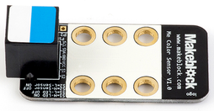
补充:主动探测（开补光LED），色板越大可测范围越大，一般取1～3cm
被动检测（关闭补光），测环境光，需要足够光照强度，无距离要求
概述：
Me Color Sensor 是一款可识别多种颜色的颜色传感器。可识别黑、黄、红、蓝、绿、白六种颜色。本模块接口是蓝白色标，说明是I2C通信模式，需要连接到主板上带有蓝白色标识接口。
Overview:
The Me Color Sensor is a color sensor capable of recognizing a total of six colors, including black, white, red, blue, yellow, and green. This module’s interface port is a standard blue-and-white, and uses I2C protocol for communication. It must be directly connected to a motherboard with a blue-and-white interface port.

技术规格：
工作电压：5V
工作电流：<5mA
工作温度：-20～60℃
信号模式：I2C通信
模块尺寸：48x24x18mm（长x宽x高）
Technical Specifications:
Operating voltage: 5V
Operating current: <5mA
Operating temperature: -20~60˚C
Signal type: I2C
Module dimensions: 48mm x 24 mm x 18 mm (LxWxH)
功能特性：
模块的白色区域是与金属梁接触的参考区域；
具有反接保护，电源反接不会损坏IC；
支持Arduino IDE编程, 并且提供运行库来简化编程；
支持mBlock图形化编程，适合全年龄用户；
使用RJ25接口连线方便；
模块化安装，兼容乐高系列。
Features:
The white region is a reference point for the attachment of the metal beam.
Contains reverse current protection; reverse current will not damage the IC.
Supports Arduino IDE programming and provides a runtime library to simplify programming.
Supports mBlock graphics programming; suitable for users of all ages.
Uses RJ25 cables for convenient connections;
offers modular installation, compatible with the Lego series.
引脚定义：
序号 | 引脚 | 功能
1 | SCL | I2C通讯（时钟管脚）
2 | SDA | I2C通讯（数据管脚）
3 | GND | 地线
4 | VCC | 电源线
5 | S1 | 补光灯控制管脚
6 | S2 | 颜色采集控制管脚
Pin diagram:

No. | Pin | Function
1 | SCL | I2C communications (clock pin)
2 | SDA | I2C communications (data pin)
3 | GND | Ground line
4 | VCC | Power line
5 | S1 | Fill light control pin
6 | S2 | Color acquisition control pin

接线方式
RJ25连接
由于颜色传感器模块接口是蓝白色色标，当使用RJ25接口时，需要连接到主控板上带有蓝白色色标的接口。以Makeblock MegaPiPro为例，可以连接到6、7、8、9、10、11、12号接口，如图
Wiring
RJ25 cable
As the color sensor module has a blue-and-white interface, when using the RJ25 cables to create a connection, it will need to be connected to the blue-and-white labeled port of the motherboard. The picture below provides an example using Makeblock MegaPiPro, in which ports 6, 7, 8, 9, 10, 11, and 12 can all be used.

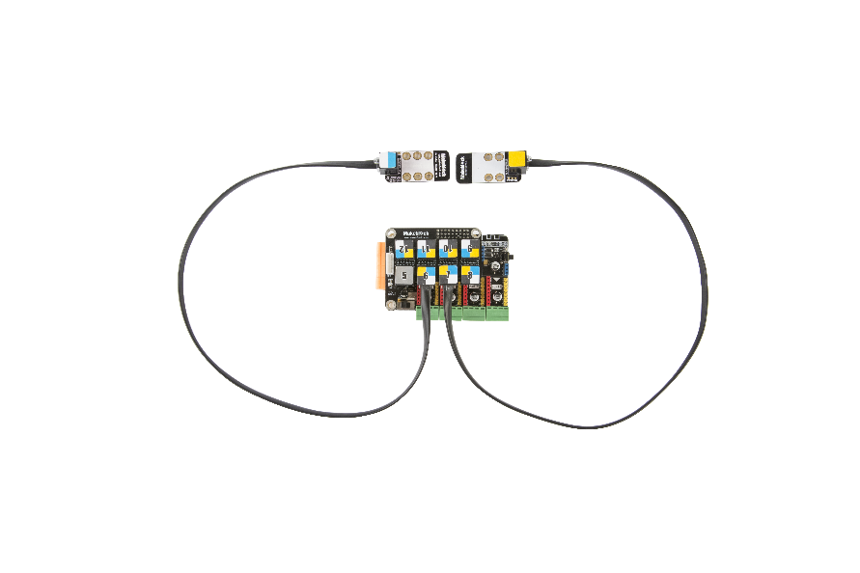

杜邦线连接:
当使用杜邦线连接到Arduino Mega2560主板的时候，模块SCL、SDA引脚需要连接到I2C接口，S1、S2引脚需要连接到数字接口，即连接到A10、A11接口如下图所示：
DuPont cable:
When using a DuPont cable to connect to the Arduino Mega2560 motherboard, the module’s SCL and SDA pins must connect to the I2C port, and the S1 and S2 pins must be connected to the digital interface, which are the A10 and A11 ports, as shown in the picture below:

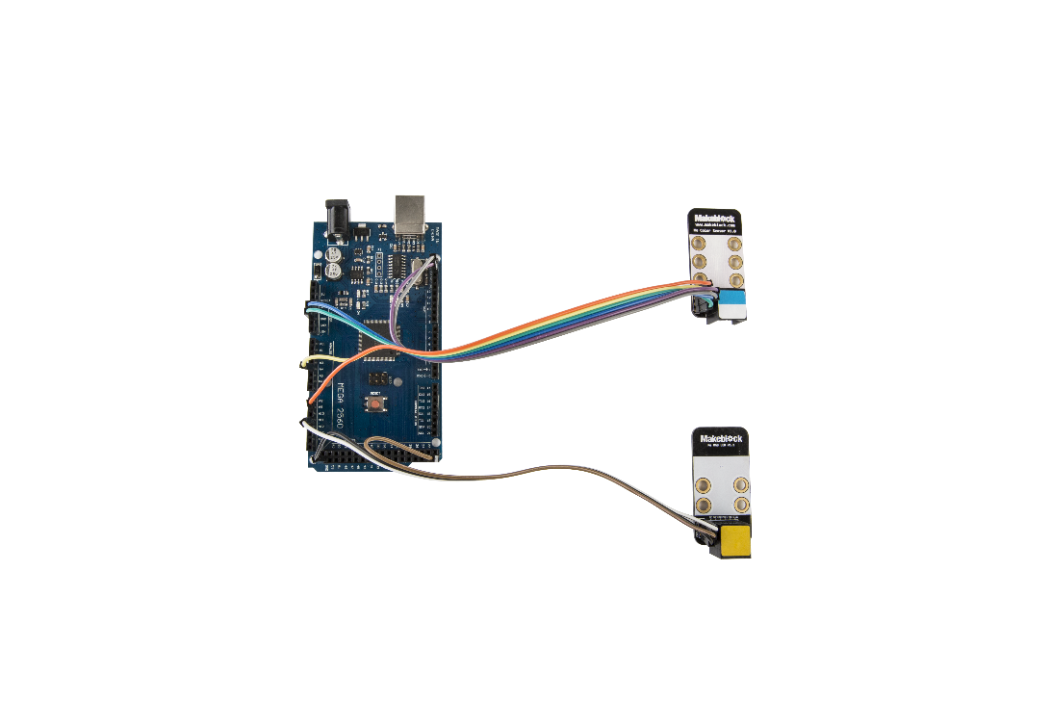
（此图中的Arduino Mega2560主板为非正版产品，请谨慎使用）
(The Arduino Mega2560 motherboard shown is not an officially registered product, please use with caution)

编程指南：
Arduino编程：
如果使用Arduino编程，需要调用库Makeblock-Library-master 来控制颜色传感器模块
本程序通过Arduino编程，使用颜色传感器识别不同颜色时，我们可通过串口监视器查看颜色数据。
Programming Guide:
Arduino programming:
If you use Arduino programming, you will need to use the Makeblock-Library- master runtime library to control the color sensor module. This program is written using Arduino; when using the color sensor to identify different colors, we can use the serial monitor to view the color data.

#include <MeMegaPiPro.h>
#include <Wire.h>
#include <MeColorSensor.h>

MeColorSensor colorsensor(PORT_6);
MeRGBLed rgbled(PORT_7);

void setup()
{
colorsensor.TurnOnLight();
colorsensor.SensorInit();
}

void loop()
{
if(colorsensor.Returnresult() == BLACK)
{
rgbled.setColor(0,20,20,20);
}
if(colorsensor.Returnresult() == YELLOW)
{
rgbled.setColor(0,255,255,0);
}
if(colorsensor.Returnresult() == RED)
{
rgbled.setColor(0,255,0,0);
}
if(colorsensor.Returnresult() == GREEN)
{
rgbled.setColor(0,0,255,0);
}
if(colorsensor.Returnresult() == BLUE)
{
rgbled.setColor(0,0,0,255);
}if (colorsensor.Returnresult() == WHITE)
{
rgbled.setColor (0,255,255,255);
}
rgbled.show();
Delay(500);
}

mBlock编程
颜色传感器模块支持mblock 编程环境，该模块指令使用简介如下：
模块 | 功能
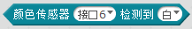 | 参数一，选择模块所连接的端口  参数二，选择目标颜色
参数一，选择模块所连接的端口
参数二，读取相应颜色值
下面是使用LED模块来显示颜色传感器所采集到的颜色：
mBlock programming
The color sensor module supports the mblock programming environment, and the module’s usage instructions are as follows:
Module | Function
Parameter 1: select the port that the module is connected to.
Parameter 2: select the target color.

Parameter 1, select the port that the module is connected to.
Parameter 2, read the corresponding color value.
The following uses the LED module to display the color data collected by the color sensor：

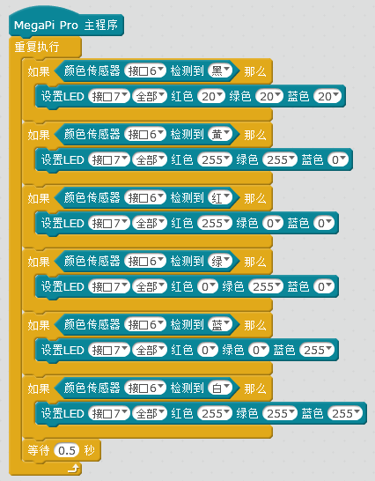

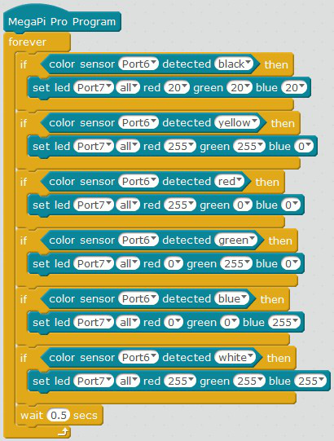

原理剖析：
颜色传感器模块集成BH1745NUC数字颜色传感器，采用分时复用方式实现多模块并联采集，单模块转换时间160mS。为减少指示灯对传感器的影响，在开启传感器电源后指示灯熄灭。
使用I2C总线读取转换结果。
使用控制方式如下：
 | LED_ON | LED_OFF
S1 | + | -
 | Sensor_ON | Sensor_OFF
S2 | - | +
开启补光灯：S1 = HIGH；关闭补光灯：S1 = LOW；
开启传感器：S2 = LOW；关闭传感器：S2 = HIGH；
Functional analysis:
The color sensor module contains an integrated BH1745NUC digital color sensor and uses time-division multiplexing to achieve multi-module parallel acquisition. It has a single-module conversion time of 160 mS. To reduce the effect of the indicator light on sensor functionality, the indicator light turns off when the sensor is turned on. The I2C bus is used to read the conversion results.

Control methods are as follows:

 | LED_ON | LED_OFF
S1 | + | -
 | Sensor_ON | Sensor_OFF
S2 | - | +
Turn on fill light: S1 = HIGH; Turn off fill light: S1 = LOW
Turn on sensor: S2 = LOW; Turn off sensor: S2 = HIGH

原理图
Wiring diagram
